XICTEK Systems HISABDO Internship
BATCH 2
Day 2 and 3 Report

Name: MARSHA ARIF MUQRI
Track: ARTIFICIAL INTELLIGENCE INTERN
GitHub: https://github.com/marsha2004/API-AI-Chatbot

INTRODUCTION:
This report documents the work completed for Day 2 and Day 3 of the AI internship task. On Day 1 a basic chatbot was created. Day 2 extended it into a complete application with a proper API integration, loading state, error handling, a clean interface and a defined system prompt. Day 3 added further improvements such as conversation history, clear chat, better prompt structure, Markdown responses, memory and response handling. Both days were implemented in a single program, app.py.

OBJECTIVES:
- Build a working a study AI chatbot with user input, AI responses and a clean interface.
- Integrate the Gemini API correctly, with a loading state and robust error handling.
- Give the chatbot a clear role and personality using a system prompt.
- Implement the following improvements: history, clear chat, prompt structure, Markdown response, memory and response and error handling.
- Implement streaming responses to reduce perceived latency and improve time-to-first-token (TTFT).
- Reduce hallucination by restricting the model with Pydantic and keeping the temperature low.

SYSTEM ARCHITECTURE:

3.1 Overview
Sage is a single-file Streamlit application with a layered design. Each user message passes through five stages: input validation, prompt building, the model call, stream handling and reply validation. Two small JSON stores provide persistence for chat history and long-term memory. Figure 1 shows the complete flow.
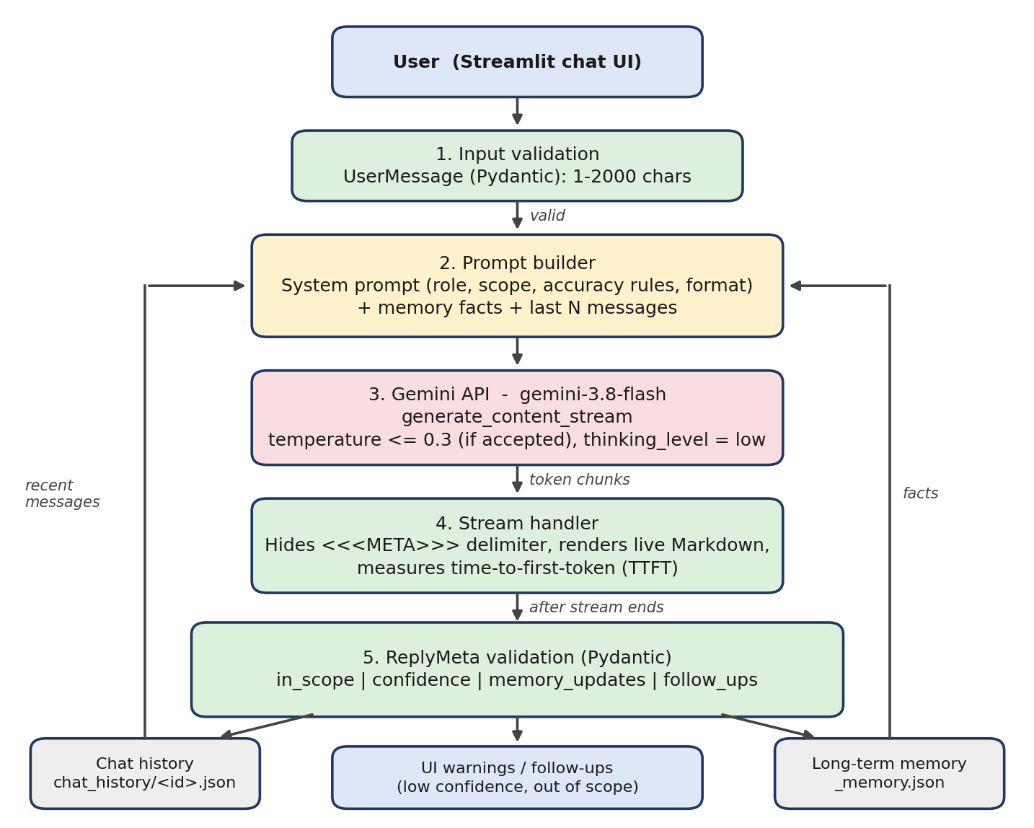
Figure 1: Request flow and data stores of the Sage chatbot

3.2 Components

- Settings (Pydantic): Holds the model name, temperature, thinking level, max tokens and context window. Temperature is constrained to 0.0 <= t <= 0.3, so an unsafe value raises a validation error.
- UserMessage (Pydantic) : Validates and cleans input: strips whitespace, rejects empty text and text above 2000 characters.
- Prompt builder: Combines the base system prompt with remembered user facts and passes it as system_instruction.
- Context window: Sends only the last N messages (default 10), always starting with a user turn, and maps roles to Gemini's user / model.
- Gemini client: genai.Client with a 60 s timeout and 3 retry attempts for transient errors (cached with st.cache_resource).
- Stream handler: Iterates over chunks, hides the metadata delimiter, updates the UI live and records TTFT.
- ReplyMeta (Pydantic): Validates the JSON block the model appends: in_scope, confidence, memory_updates, follow_ups.
- History storage: One JSON file per chat in chat_history/, listed in the sidebar by most recent.
- Memory store: memory.json with up to 20 de-duplicated user facts, injected into later prompts.

What I Learned:
• Streaming improves experience, not total speed. It lowers perceived latency because the user reads while the rest is generated. TTFT is the most meaningful metric for a chat application.
• A system prompt is a specification. Role, scope, honesty rules and a fixed output format changes the model's behaviour far more than a one-line persona.
• Treat model output as untrusted input. Validating it with Pydantic before using it prevents bad data from reaching the rest of the program.
• LLMs have no memory. "Memory" is only what the application places back into the prompt on each request.
• Different failures need different messages. Authentication, quota, timeout and network errors each tell the user something different to do.
• Streamlit re-runs the whole script on each interaction, so state must live in st.session_state or on disk.
• Internal data files must be kept separate from user data, or a directory listing can read the wrong file.
• Testing small helper functions with a mock client catches bugs without spending API quota.

Problems and Solutions:

# | PROBLEM | SOLUTION
1 | Strict JSON output conflicts with streaming, because partial JSON looks broken to the user. | The reply is split into a streamed Markdown answer and a trailing <<<META>>> JSON block. Only the first part is displayed; the JSON is validated when the stream ends.
2 | The delimiter can arrive split across chunks, briefly flashing text such as <<<ME on screen. | visible_part() holds back any trailing text that could be the start of the delimiter.
3 | The model sometimes omits or malforms the metadata JSON. | parse_meta() returns None on any validation error; the UI shows an "unverified" notice and stores no memory from that reply.
4 | Documentation disagrees on whether Gemini 3.x accepts a custom temperature. | Try 0.2 first; on a 400 error mentioning temperature, retry once without it and show a sidebar note. thinking_level="low" is always applied.
5 | Hallucination on uncertain or off-topic questions. | Scope rules, honesty rules, confidence and scope flags, a temperature cap and Pydantic validation (Section 5).
6 | API errors crashed the application. | Status-code-specific handling, SDK retries, a timeout, and removal of the failed message so it can be resent.
7 | Streamlit re-runs the script and loses variables. | State stored in st.session_state; chat and memory persisted to JSON files.
8 | nonlocal caused a SyntaxError because Streamlit executes the script at module level. | Replaced the closure variable with a small dictionary (timing["ttft"]).
9 | AttributeError: 'list' object has no attribute 'get' in the history list. | The memory file (_memory.json, a list) was being read as a chat. The loader now skips files starting with _ and accepts only dictionaries containing id and messages.
10 | Context grows with every turn, increasing cost and latency. | Sliding window of the last N messages plus compact long-term memory.

